Good afternoon, I was discussing earlier, you just need to get the adapters to tie into our terminals… Here’s the adapter I was referencing as well: https://www.amazon.com/Serial-Communication-Converter-Adapter-Mini-Size/dp/B0196AO1IG

- Use the RS485 with 23/24/25 output
- Use the RS232 with 26/27/28 output
- See example pic and chart below
- Manual attached, DGTP

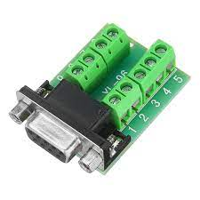
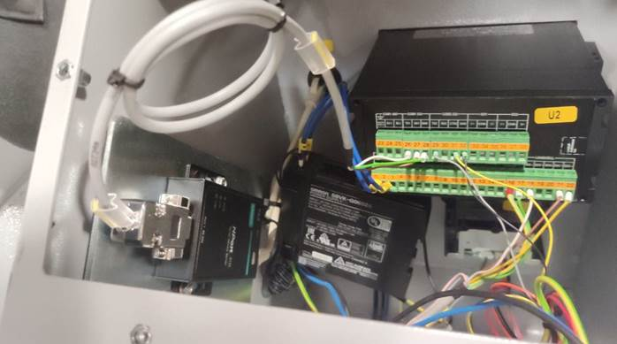

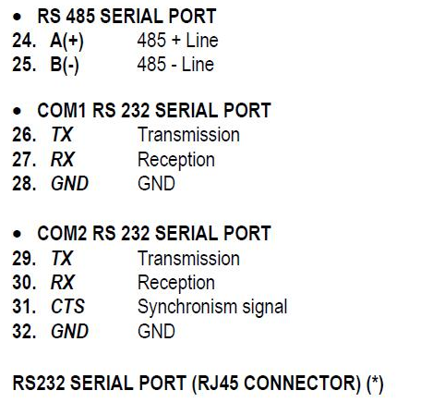

Nick Szczechowski
Regional Sales Manager
ROBOPAC USA
mobile: (224)266-0174
site: www.robopacusa.com

