How to Program your Screen/Board (Kinco/Black Screen)
Please read the following information carefully on how to program your machine. No matter what part you replace you must program all parts listed in this guide. Failure to do so will result in software incompatibility between parts, causing further issues using your machine.
Programming your U1 & U3 Board:
Turn the machine OFF, insert the USB pen-drive into the (J10) port, then turn the machine ON. The LD5 orange led will blink, indicating that the software is downloading to the board. Upon completion the orange led LD5 will turn OFF, and the green led LD7 will begin to blink, indicating that the new software is running. Repeat for the other board.
Programming your HMI:
- Turn over your HMI and place the dip switches behind the screen on “SETUP MODE” as shown on the chart you will see on the back of the screen (In case you don’t see this, Setup Mode is ON-ON). Install the screen and place your installation USB into the USB port on the machine mast to the left of the screen. Power on the screen and you will see the below screen after selecting the language. Select the two options as shown below:
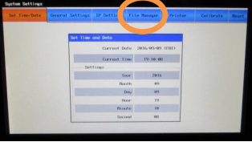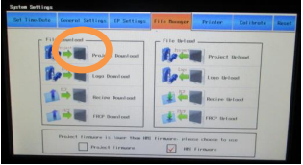
- Select “usb1/” in this menu and confirm a “.pkg” file is shown in the top-right window. Once confirmed press “OK.” Once “Load PKG OK!” message generates, the download has succeeded. You will need to make some changes to the screen settings next.
- Follow the following button path left to right to login and change your language setting back to English:

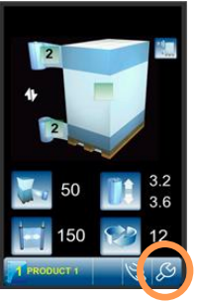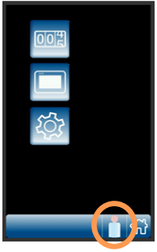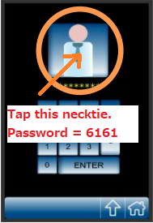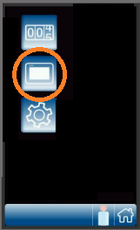
Tap the Italian flag on the next screen until you see the UK flag:
- Follow the following button path to correct your parameters:
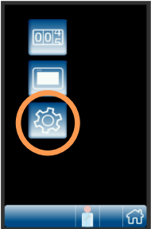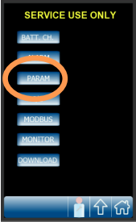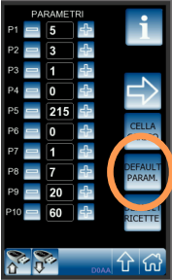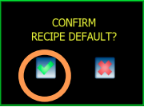
Once defaulted you will need to change the following settings. Please press the “i” in the top-right corner to see the names of the settings:
Carriage -> If PVS = 5. If PDS = 4 (carriage type is written on the serial sticker)
USA Display Enable = 1
Cut enable = 1
- Remove the screen and return the dip switches to RUN Mode (ON-ON) as shown in the chart. Reinstall the screen to complete the process.

